1-What is Test Case
Lecture 2- How to Write Test Cases for User Story - start at 0:43

2-Test Case Structure
Lecture 2- How to Write Test Cases for User Story - start at 1:51
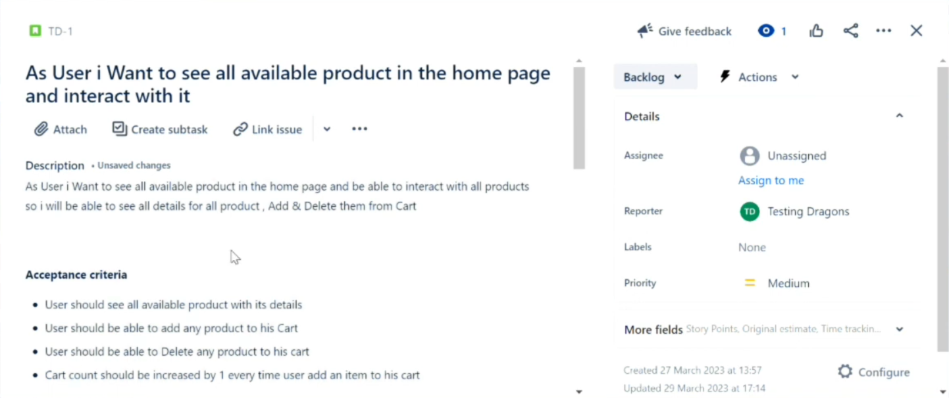
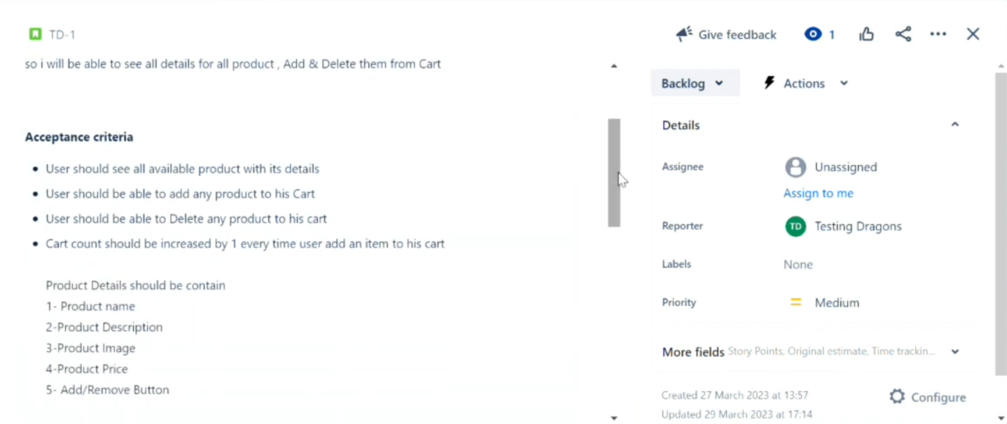
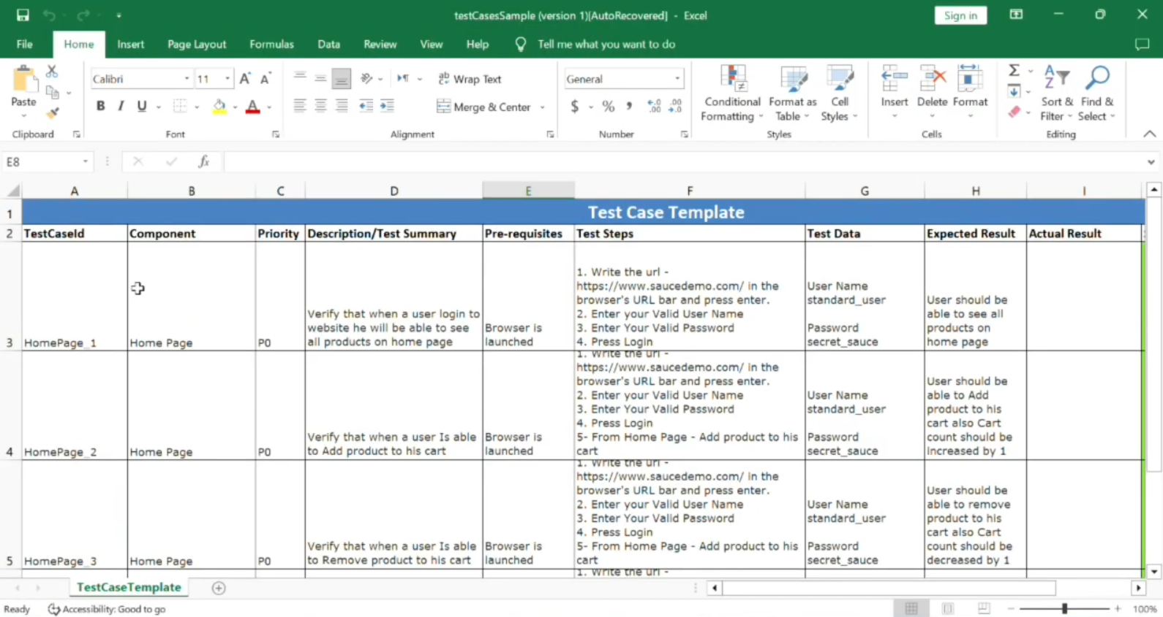
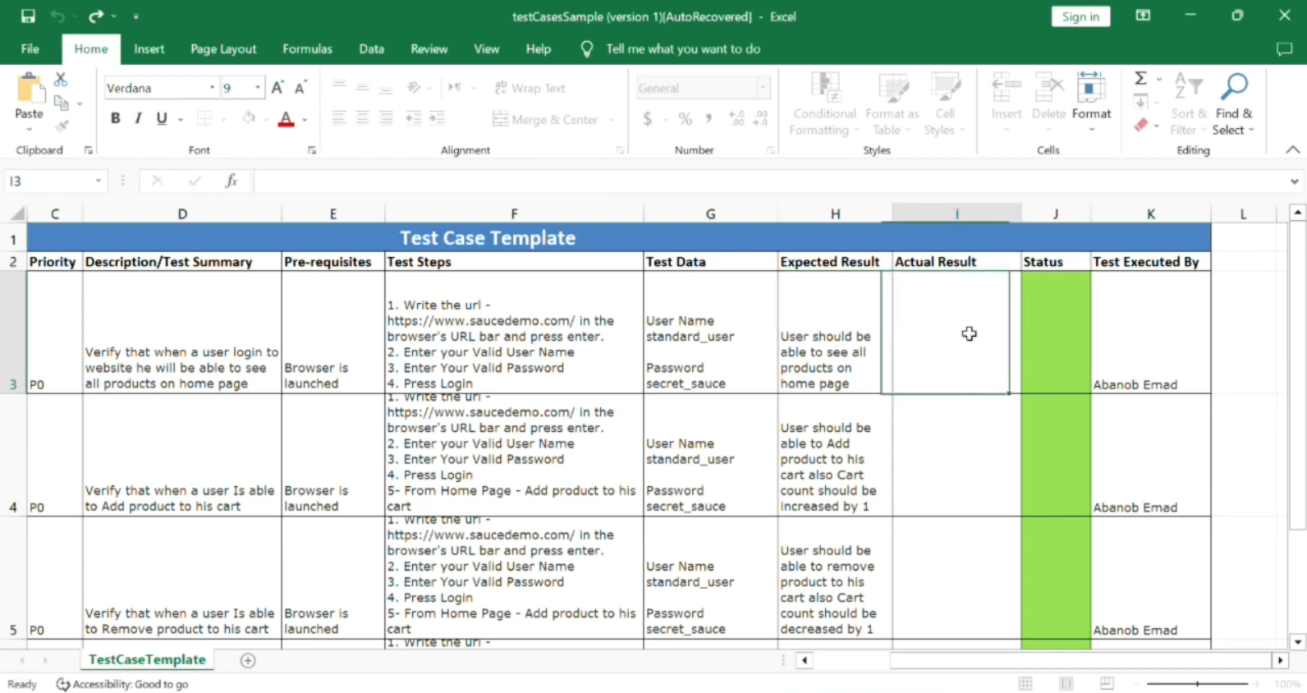

3-Test Case Example
Lecture 2- How to Write Test Cases for User Story - start at 8:59
